Leeks Information Pack
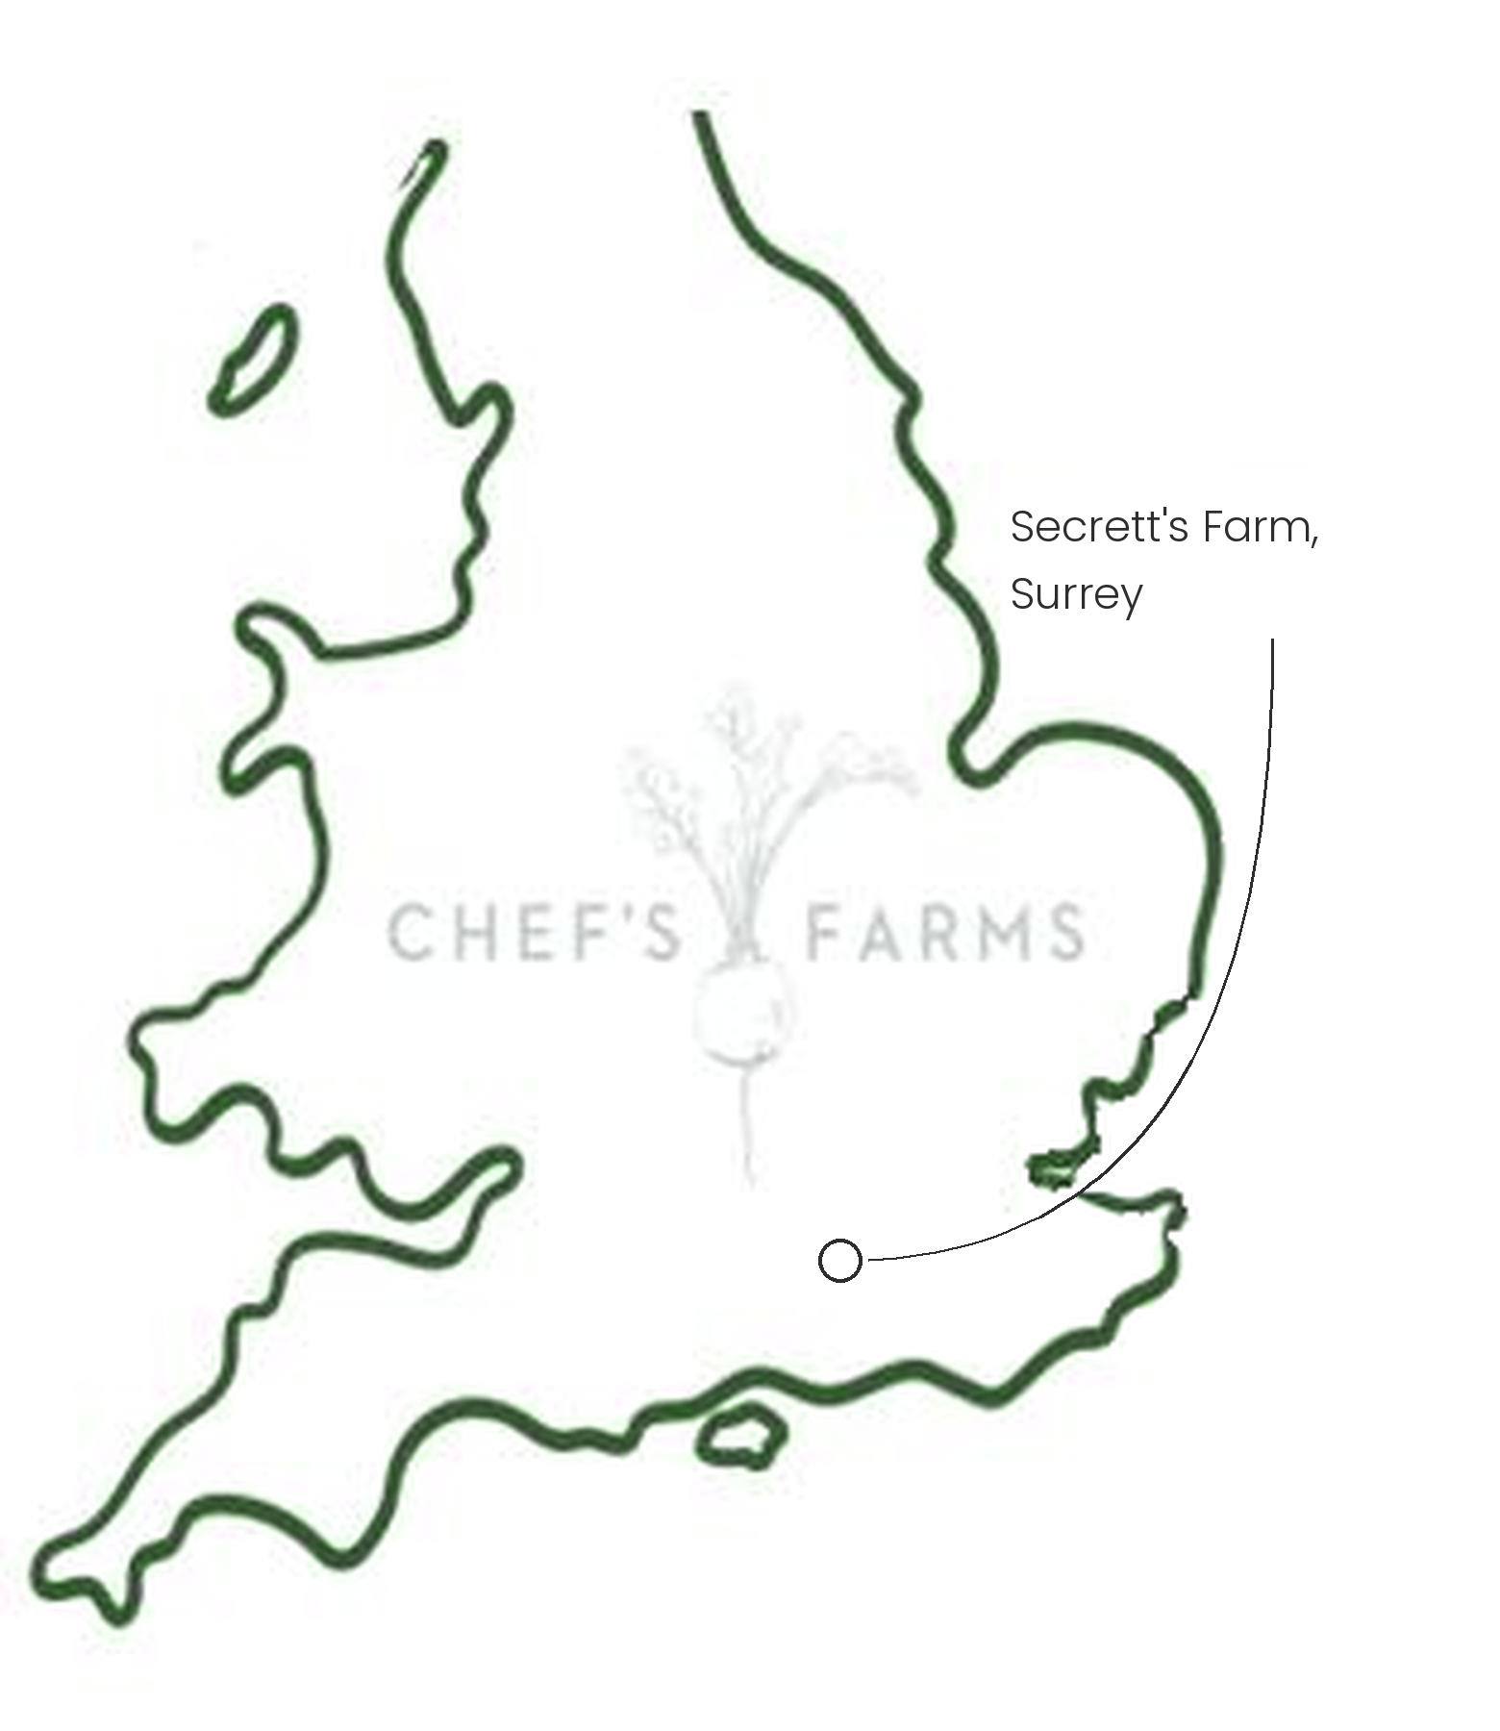
Introduction
Leeks are a member of the allium family, alongside onions and garlic. They are one of the hardiest crops grown in the UK, standing in the field through winter and harvested as needed from autumn through to spring.
Farm Information
Our leeks are grown by Greg Secrett and the team at Secrett's Farm in Surrey. Greg harvests all of his crops to order, hugely reducing waste and guaranteeing freshness, so your leeks are lifted for your order rather than sitting in a store.
The long white shank that chefs prize doesn't happen by accident. Leeks are planted deep and the soil is drawn up around the stems as they grow, keeping the light off so the stem stays white, tender and sweet. The farm's sandy-loam soil drains well and is easy to work, which makes this much simpler and means the leeks come out of the ground cleaner.
Alliums need a long break between plantings to keep soil-borne diseases and pests at bay, so the leeks are grown as part of a diverse rotation alongside the farm's herbs, salads and roots. The team avoids monocropping and uses natural composts to keep the soil healthy, with minimal synthetic inputs.
More
The season runs from early autumn through to spring. Nothing needs to go to waste either: the white is perfect for braising whole or charring over the grill, while the darker green tops make a sweet, rich base for stocks and sauces.
Nutritionally, leeks are a good source of vitamin K, folate and manganese, and contain inulin, a fibre that feeds the good bacteria in the gut.
Media
See shared album

